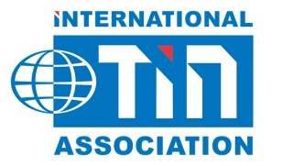

2018 London Tin Seminar Registration Form
There is no registration fee for this seminar

Company Name：
First Name： | Last Name：
Position： | E-mail：
Dietary Requirements：
Do you give your permission for us to distribute your contact details to other seminar participants? (Type Yes/No):

E-mail completed form to：conferencing@internationaltin.org

