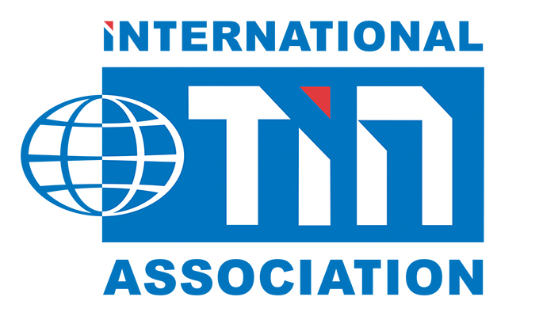
PRESS RELEASE
19th November 2018 Ref: 11-19-TOP100WOMEN
Responsible tin pioneer named in Top 100 Women in Mining
The Women in Mining organisation has recognised the pioneering work of Kay Nimmo at the International Tin Association in achieving practical solutions to the challenges of responsible minerals sourcing. Kay has worked tirelessly over the past decade to create and implement industry-leading initiatives which achieve real impacts, including the ITSCI programme to resolve conflict mineral concerns, and more recently the tin industry Code of Conduct.

WIM is a non-profit organisation dedicated to promoting the development of women in the mining sector who this year received 642 nominations from the industry worldwide for women considered inspirational, making the effort to go above and beyond their daily responsibilities. Kay was selected for the Top 100 listing based on criteria such as perseverance in the face of adversity and a trail-blazing approach. The 2018 edition of “Top 100 Global Inspirational Women in Mining”, co-sponsored by BMO Capital Markets, was launched at the Landsdowne Club, London on 15th November.

“Of course I am delighted to have been honoured, and to have the opportunity to support the important work of Women in Mining and provide inspiration for all women in the mining sector” said Kay “I enjoy new challenges and I have certainly faced many in setting new standards for responsible minerals sourcing in a traditional industry sector, and in particular for tin for which artisanal and small scale mining is an important supply source. I am privileged to have had the chance to influence and improve gender equality as a part of my work”

Kay set-up and has led work on sustainability at the International Tin Association for more than fifteen years, becoming involved in mining through personally pioneering and growing the ITSCI responsible sourcing programme since 2008. ITSCI is now the leading initiative enabling large volume minerals trading from the high risk areas of DRC Congo and neighbouring countries in Central Africa while avoiding contributing to conflict and human rights abuses. The work requires high level detailed integration with governmental and industry frameworks as well as liaising with project partners and her team with day-to-day oversight of practical field activities and corporate membership.

ITSCI has forged efforts to support women in mining in the region. Kay and her team at the NGO Pact Inc were considered by the Gender Resource Facility advising the Netherlands Ministry of Foreign Affairs to have achieved exceptional work in Africa providing an unparalleled example to the world for all stakeholders to learn from, follow and adapt.

Now Kay is using her considerable experience and understanding of global mining practices and sustainability standards to create and implement a tin industry Code of Conduct. This new initiative, addressing wide ranging standards and supply chain performance is unique within the metals industry, and enables tin producers who are member of the International Tin Association to demonstrate leadership in progressively contributing to positive social, economic and environmental outcomes. Tin producers issued their first reports in October.

More information about Women in Mining and a copy of the 2018 edition of “Top 100 Global-Inspirational Women in Mining” can be accessed at their website here: https://www.womeninmining.org.uk

See also the International Tin Association work on responsible tin on their website here:
https://www.internationaltin.org/responsible-tin/

-ENDS-

About International Tin Association:
The International Tin Association (formerly ITRI) is the world's foremost authority on tin with over 80 years’ experience in tin related technologies. It is a membership based organisation representing major tin producers and smelters and is the premier source of tin related information. ITA has specialist knowledge of tin use in all the major sectors as well as groups responsible for statistical and market information, future uses, regulatory affairs and sustainability. It provides links to the main tin consuming sectors through a substantial network of industry contacts. The organisation hosts seminars and international conferences. It also provides marketing and technical support to its members and the tin industry in general. Further information can be obtained from http://www.internationaltin.org

For further enquiries please contact:

Kay Nimmo  Manager, Sustainability & Regulatory Affairs  Tel: + 44 (0) 1727 871312  Email: kay.nimmo@internationaltin.org | Dr Jeremy Pearce  Market Intelligence & Communications  Tel: +44 (0) 1727 871311  Mob: +44 (0)79 09890630  Email: jeremy.pearce@internationaltin.org

